Percentile report

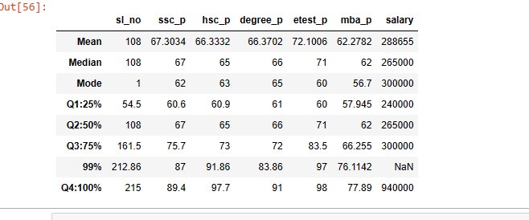

10th(sslc):

* Percentile of 10th pass mark for Q1:25% is 60 and Q2:50% data is 67 and there is 25% gap between Q1 and Q2 with 7% increment.
* Percentile of 10th pass mark for Q2:50% is 67 and Q3:75% data is 75 and there is 25% gap between Q2 and Q3 with 8% increment.
* Percentile of 10th pass mark for Q3:75% is 75 and 99% data is 87 and there is 24% gap between Q3 and 99% with 12% increment.
* Percentile of 10th pass mark for 99% is 87 and Q4:100% of data is 89 and there is 1% gap between 99 and Q4 with 2% increment.

12th(hsc):

* Percentile of 12th pass mark for Q1:25% is 60 and Q2:50% data is 65 and there is 25% gap between Q1 and Q2 with 5% increment.
* Percentile of 12th pass mark for Q2:50% is 65 and Q3:75% data is 73 and there is 25% gap between Q2 and Q3 with 8% increment.
* Percentile of 12th pass mark for Q3:75% is 73 and 99% data is 91 and there is 24% gap between Q3 and 99% with 18% increment.
* Percentile of 12th pass mark for 99% is 91 and Q4:100% of data is 97 and there is 1% gap between 99 and Q4 with 6% increment.

Degree:

* Percentile of degree pass mark for Q1:25% is 61 and Q2:50% data is 66 and there is 25% gap between Q1 and Q2 with 5% increment.
* Percentile of degree pass mark for Q2:50% is 66 and Q3:75% data is 72 and there is 25% gap between Q2 and Q3 with 6% increment.
* Percentile of degree pass mark for Q3:75% is 72 and 99% data is 83 and there is 24% gap between Q3 and 99% with 11% increment.
* Percentile of degree pass mark for 99% is 83 and Q4:100% of data is 91 and there is 1% gap between 99 and Q4 with 8% increment.

etest:

* Percentile of etest pass mark for Q1:25% is 60 and Q2:50% data is 71 and there is 25% gap between Q1 and Q2 with 11% increment.
* Percentile of etest pass mark for Q2:50% is 71 and Q3:75% data is 83 and there is 25% gap between Q2 and Q3 with 8% increment.
* Percentile of etest pass mark for Q3:75% is 83 and 99% data is 97 and there is 24% gap between Q3 and 99% with 14% increment.
* Percentile of etest pass mark for 99% is 97 and Q4:100% of data is 98 and there is 1% gap between 99 and Q4 with 1% increment.

MBA:

* Percentile of MBA pass mark for Q1:25% is 57 and Q2:50% data is 62 and there is 25% gap between Q1 and Q2 with 5% increment.
* Percentile of MBA pass mark for Q2:50% is 62 and Q3:75% data is 66 and there is 25% gap between Q2 and Q3 with 4% increment.
* Percentile of MBA pass mark for Q3:75% is 66 and 99% data is 76 and there is 24% gap between Q3 and 99% with 10% increment.
* Percentile of MBA pass mark for 99% is 76 and Q4:100% of data is 77 and there is 1% gap between 99 and Q4 with 1% increment.